Screenshots of Pass Task 4.1:
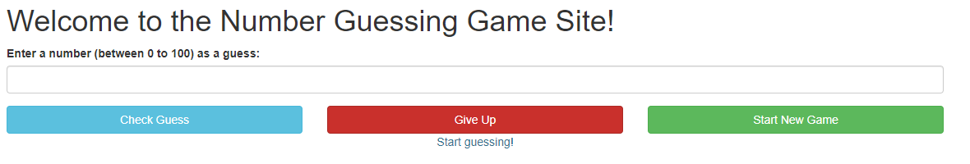
Figure 1: Load Page First Time

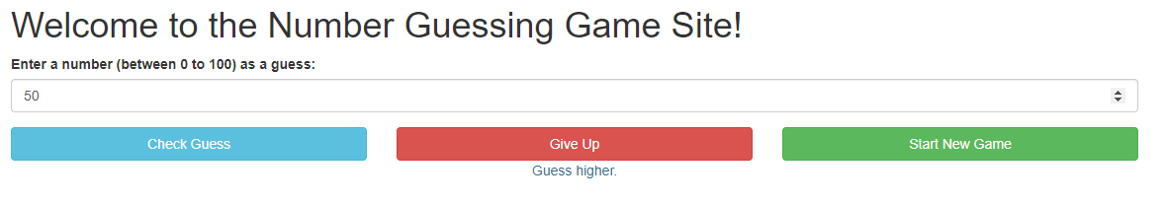
Figure 2: Guessing Pt1

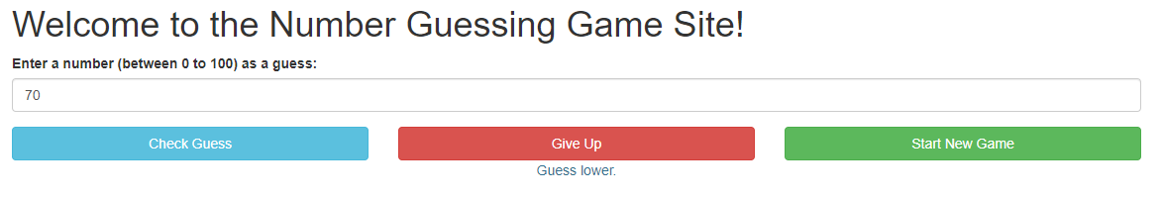
Figure 3: Guessing Pt2

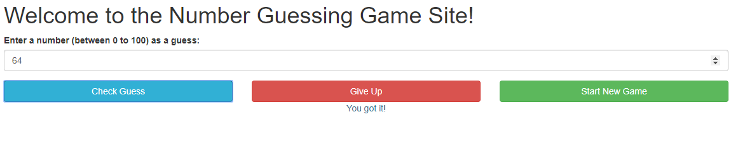
Figure 4: Guessing Pt3
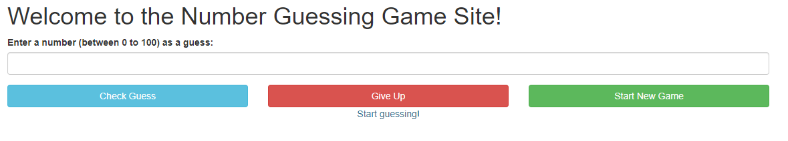
Figure 5: Starting a New Game using Button

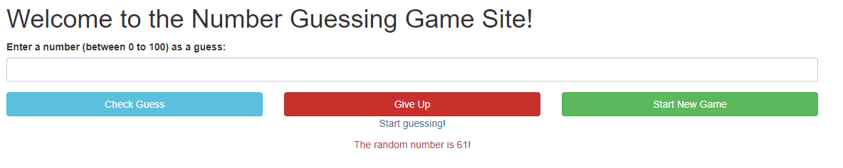
Figure 6: Show Number after New Game

